CRYPT ALGORITHM

AIM: To write a python program for Crypt Algorithm.

OBJECTIVES:
- To understand the basic concept of cryptography.
- To perform simple encryption using character shifting.
- To decrypt the encrypted message and obtain the original text.

ALGORITHM:
- Start the program.
- Read a message from the user.
- Set the key value as 3.
- Encrypt each character by shifting it forward by 3 positions.
- Display the encrypted message.
- Decrypt the message by shifting each character backward by 3 positions.
- Display the original message.
- Stop the program.

SYSTEM ARCHITECTURE:
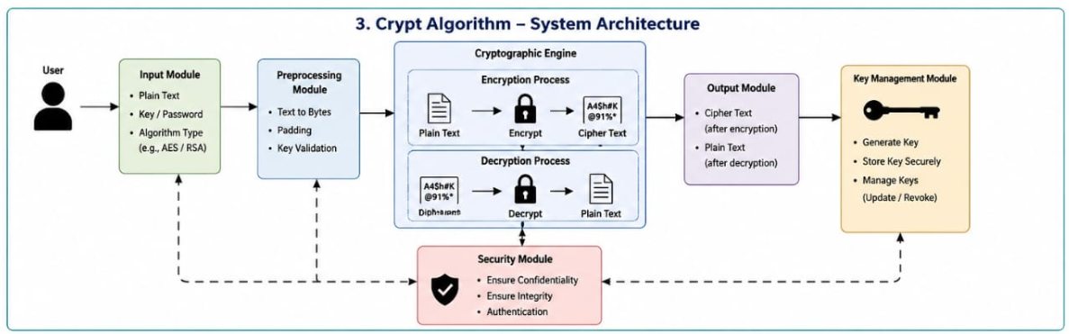

PROGRAM:
text = input("Enter text: ")
key = 3
enc = ""
for i in text:
enc += chr(ord(i) + key)
print("Encrypted:", enc)
dec = ""
for i in enc: dec += chr(ord(i) - key)
print("Decrypted:", dec)
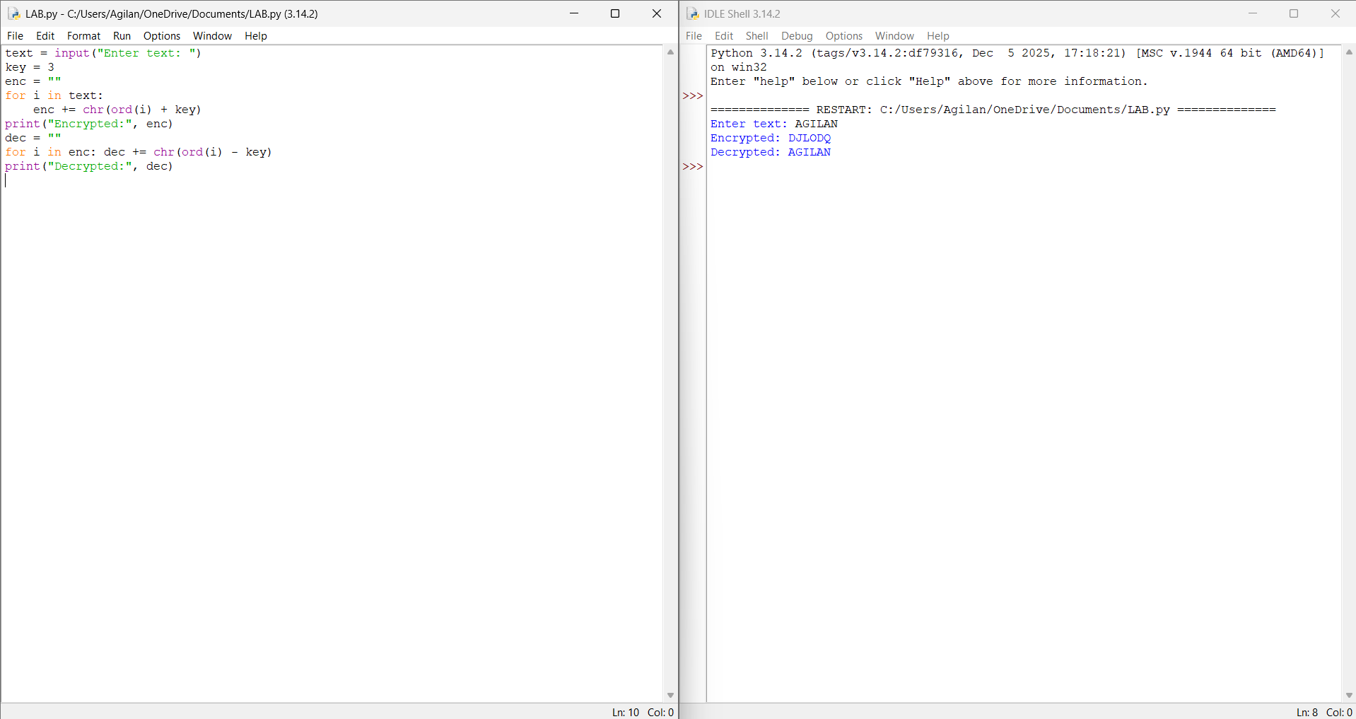

RESULT: Thus the Crypt algorithm is implemented successfully using python language.

